Getting started with SENGUARD
  - A step-by-step guide for Neighbourhood Watch Scotland coordinators
SENGUARD is a free app that helps protect you from online scams. It checks links and websites as you browse and warns you before you reach a dangerous page. Setting it up takes most people only a few minutes, and this guide walks you through every step.

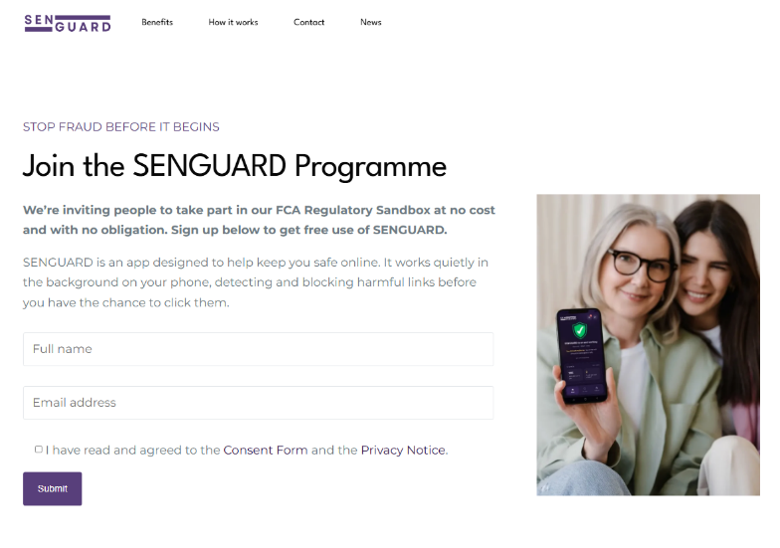
Step 1 Register
Go to https://senguard.co.uk/participate on any device or scan the QR code below. Enter your email address and choose a password.
Keep a note of both, as you will need them again in Step 4.

Step 2 Install the app
Once registered, install the free SENGUARD app on your smartphone or tablet.
iPhone or iPad: Click here (opens the App Store)
Android phone or tablet: Click here (opens Google Play)
The app is always free. You will never be asked to pay or to enter card details.

Step 3 Allow the protections to switch on
When you first open the app, it will guide you through switching on the permissions SENGUARD needs to protect you. Your device will show its own confirmation screens, which is normal. Here is what each permission does and why it is needed.
VPN configuration. This lets SENGUARD check the addresses of websites before they load, so it can stop a dangerous page before you reach it.

VPN Permission Tip
Your phone will show a "SENGUARD wants to set up a VPN connection..." notification with an “OK” button.

Accessibility (Android only). This lets SENGUARD spot dangerous links in the apps you use, not just your web browser. SENGUARD does not read your messages, emails or passwords.

Accessibility Tip
For Android phones this is within: Settings → Accessibility → installed apps section → toggle on → confirm. It’s possible your screen may look slightly different.

These permissions are safe to allow and the protection cannot work without them. SENGUARD only ever uses them to keep you safe, never to watch what you do.

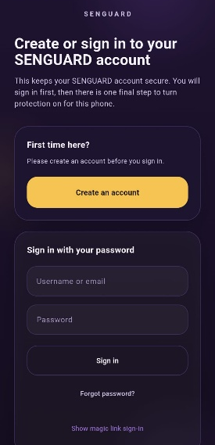
Step 4 Log in
Log in to the app using the same email address and password you created in Step 1. Once you are logged in, SENGUARD is working. You do not need to open the app again for it to protect you.

Step 5 You are in control
You can stop taking part at any time, for any reason. Simply uninstall the app the same way you would remove any other app and your participation ends.
If you do decide to remove it, we would be grateful if you could tell us why using the contact details below so we can keep improving.

What to expect once you are set up
SENGUARD works quietly in the background. Most of the time you will not notice it at all.
If you visit a dangerous page, you will see a clear warning screen before it loads, explaining the risk in plain language. Stop, do not enter any details, and close the page.

Need a hand?

Email us at protect@senguard.co.uk and we will respond within two working days.

SENGUARD is a participant in the FCA Regulatory Sandbox. The service is being tested with real users as part of that programme and your feedback directly shapes how it develops.

Participation in the Sandbox is not approval or endorsement by the FCA.

FCA Programme confirmation
Search “SENGUARD” in the search field on the following official FCA page: https://www.fca.org.uk/firms/innovation/regulatory-sandbox/accepted-firms

